# Best Programming Practice

1. All values as variables including Fixed, User Inputs, and Results
2. Avoid Hard Coding of variables wherever possible
3. Proper naming conventions for all variables String name = "Eric"; double height = input.nextDouble();

double totalDistance = distanceFromToVia + distanceViaToFinalCity;

1. Proper Program Name and Class Name
2. Follow proper indentation

1. **Sample Program 1 -** Write a program to display Sam with Roll Number 1, Percent Marks

99.99, and the result ‘P’ indicates Pass(‘P’) or Fail (‘F’).

IMP => Follow Good Programming Practice demonstrated below in all Practice Programs

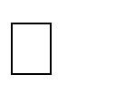// Creating Class with name DisplayResult indicating the purpose is to display

// result. Notice the class name is a Noun. class DisplayResult {

public static void main(String[] args) {

// Create a string variable name and assign value Sam

String name = "Sam";

// Create a int variable rollNumber and assign value 1 int rollNumber = 1;

// Create a double variable percentMarks and assign value 99.99 double percentMarks = 99.99;

// Create a char variable result and assign value 'P' for pass

char result = 'P';

// Display the result

System.out.println("Displaying Result:\n" +name+ " with Roll Number " + rollNumber+ " has Scored " +percentMarks+

"% Marks and Result is " +result);

}

}

2. **Sample Program 2 -** Eric Travels from Chennai to Bangalore via Vellore. From Chennai to Vellore distance is 156.6 km and the time taken is 4 Hours 4 Mins and from Vellore to Bangalore is 211.8 km and will take 4 Hours 25 Mins. Compute the total distance and total time from Chennai to Bangalore

// Create TravelComputation Class to compute the Distance and Travel Time class TravelComputation {

public static void main(String[] args) {

// Create a variable name to indicate the person traveling

String name = "Eric";

// Create a variable fromCity, viaCity and toCity to indicate the city

// from city, via city and to city the person is travelling

String fromCity = "Chennai", viaCity = "Velore", toCity = "Bangalore";

// Create a variable distanceFromToVia to indicate the distance

// between the fromCity to viaCity double distanceFromToVia = 156.6;

// Create a variable timeFromToVia to indicate the time taken to

// travel from fromCity to viaCity in minutes int timeFromToVia = 4 * 60 + 4;

// Create a variable distanceViaToFinalCity to indicate the distance

// between the viaCity to toCity double distanceViaToFinalCity = 211.8;

// Create a variable timeViaToFinalCity to indicate the time taken to

// travel from viaCity to toCity in minutes int timeViaToFinalCity = 4 * 60 + 25;

// Create a variable totalDistance to indicate the total distance

// between the fromCity to toCity

double totalDistance = distanceFromToVia + distanceViaToFinalCity;

// Create a variable totalTime to indicate the total time taken to

// travel from fromCity to toCity in minutes int totalTime = timeFromToVia + timeViaToFinalCity;

// Print the travel details

System.out.println("The Total Distance travelled by " + name + " from " + fromCity + " to " + toCity + " via " + viaCity +

" is " + totalDistance + " km and " +

"the Total Time taken is " + totalTime + " minutes");

} }

# Level 2 Practice Programs

1. Write a program to create a basic calculator that can perform addition, subtraction, multiplication, and division. The program should ask for two numbers (floating point) and perform all the operations

**Hint =>**

* 1. Create a variable number1 and number 2 and take user inputs.
  2. Perform Arithmetic Operations of addition, subtraction, multiplication and division and assign the result to a variable and finally print the result

**I/P =>** number1, number2

**O/P =>** The addition, subtraction, multiplication and division value of 2 numbers ___ and ___ is ___, ____, ____, and ___

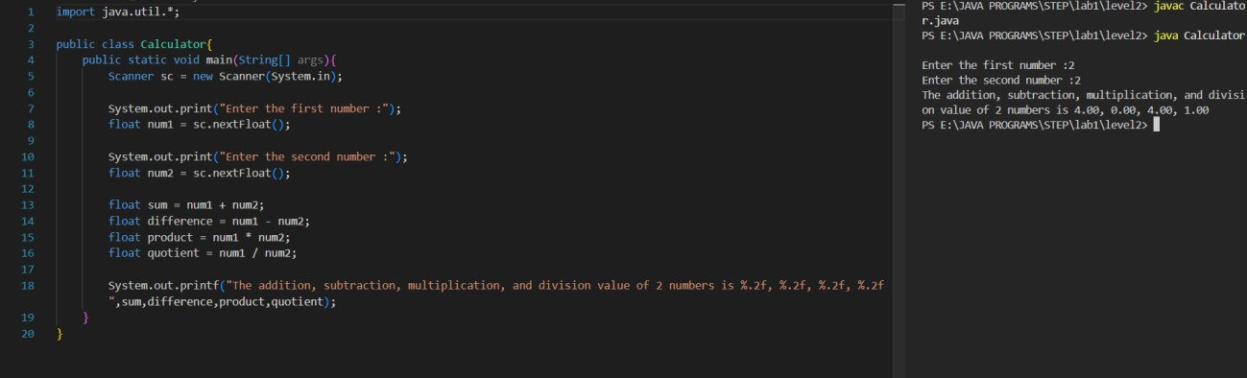

1. Write a program that takes the base and height to find area of a triangle in square inches and square centimeters

**Hint =>** Area of a Triangle is ½ * base * height

**I/P =>** base, height

**O/P =>** Your Height in cm is ___ while in feet is ___ and inches is ___

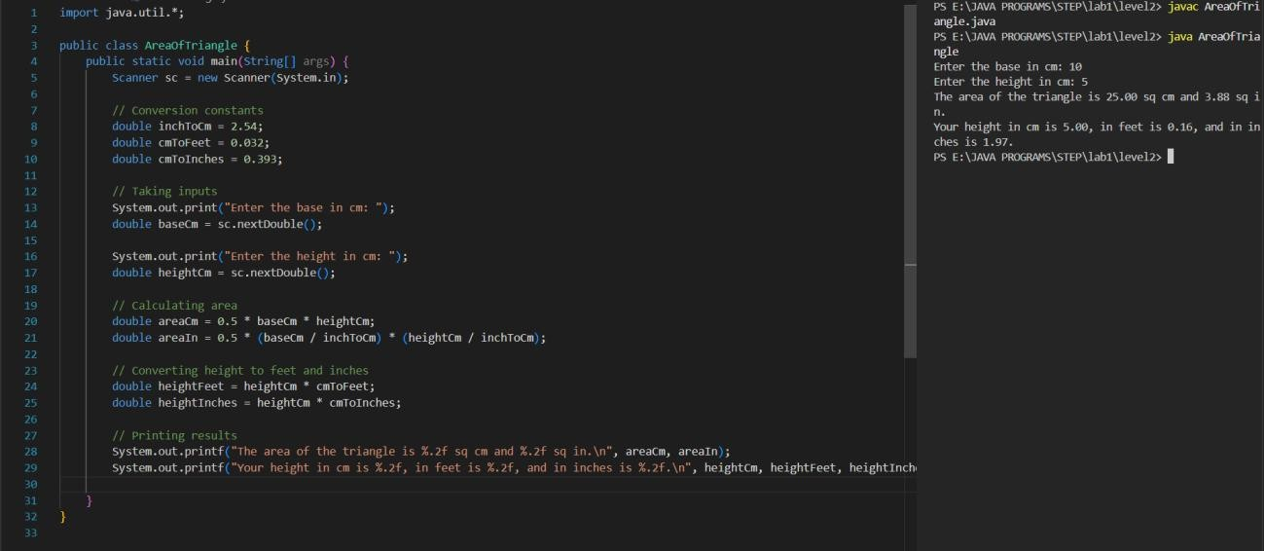

1. Write a program to find the side of the square whose parameter you read from user

**Hint =>** Perimeter of Square is 4 times side

**I/P =>** perimeter

**O/P =>** The length of the side is ___ whose perimeter is ____

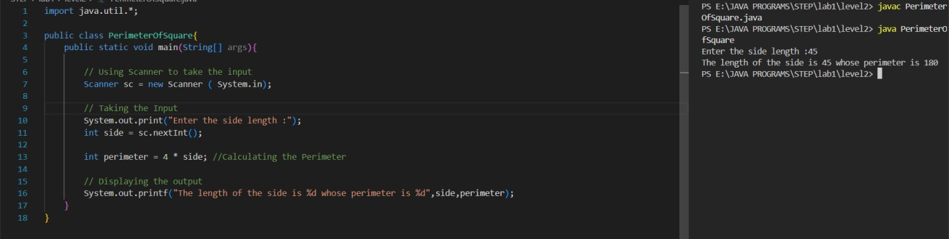

1. Write a program the find the distance in yards and miles for the distance provided by user in feets

**Hint =>** 1 mile = 1760 yards and 1 yard is 3 feet

**I/P =>** distanceInFeet

**O/P =>** Your Height in cm is ___ while in feet is ___ and inches is ___

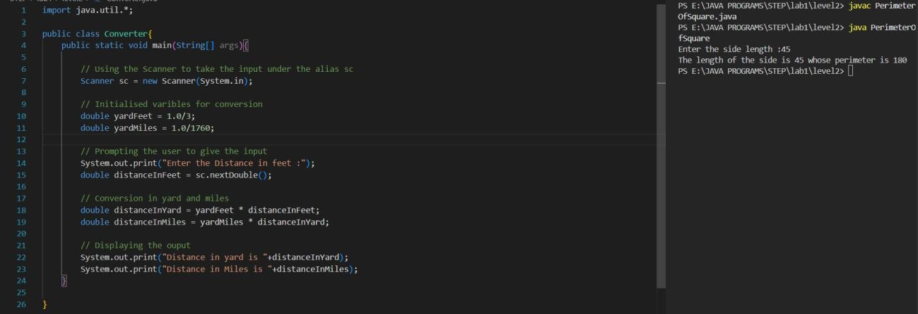

1. Write a program to input the unit price of an item and the quantity to be bought. Then, calculate the total price.

**Hint =>** NA

**I/P =>** unitPrice, quantity

**O/P =>** The total purchase price is INR ___ if the quantity ___ and unit price is INR ___

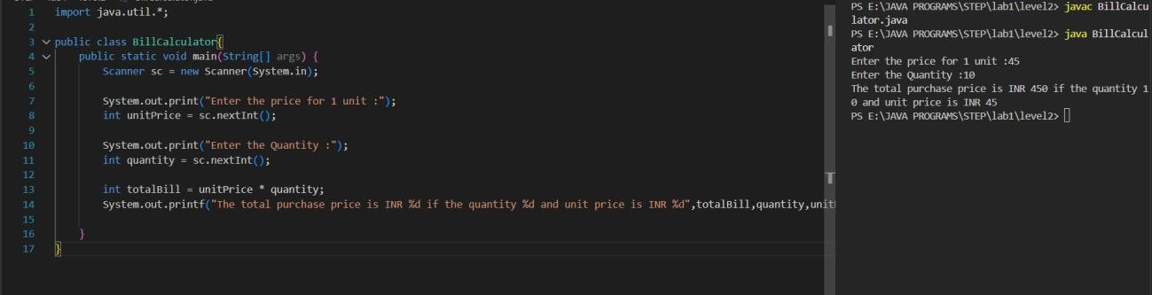

1. Write a program to take 2 numbers and print their quotient and reminder

**Hint =>** Use division operator (/) for quotient and moduli operator (%) for reminder

**I/P =>** number1, number2

**O/P =>** The Quotient is ___ and Reminder is ___ of two number ___ and ___

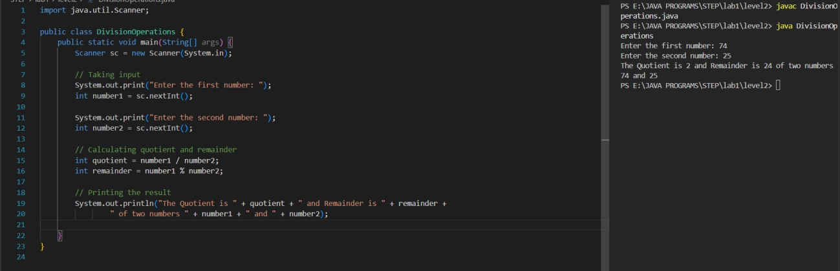

1. Write an ***IntOperation*** program by taking a, b, and c as input values and print the following integer operations a + b *c, a * b + c, c + a / b, and a % b + c. Please also understand the precedence of the operators.

**Hint =>**

* 1. Create variables a, b, c of int data type.
  2. Take user input for a, b, and c.
  3. Compute 3 integer operations and assign the result to a variable
  4. Finally, print the result and try to understand operator precedence.

**I/P =>** fee, discountPrecent

**O/P =>** The results of Int Operations are —-, -—, and —-

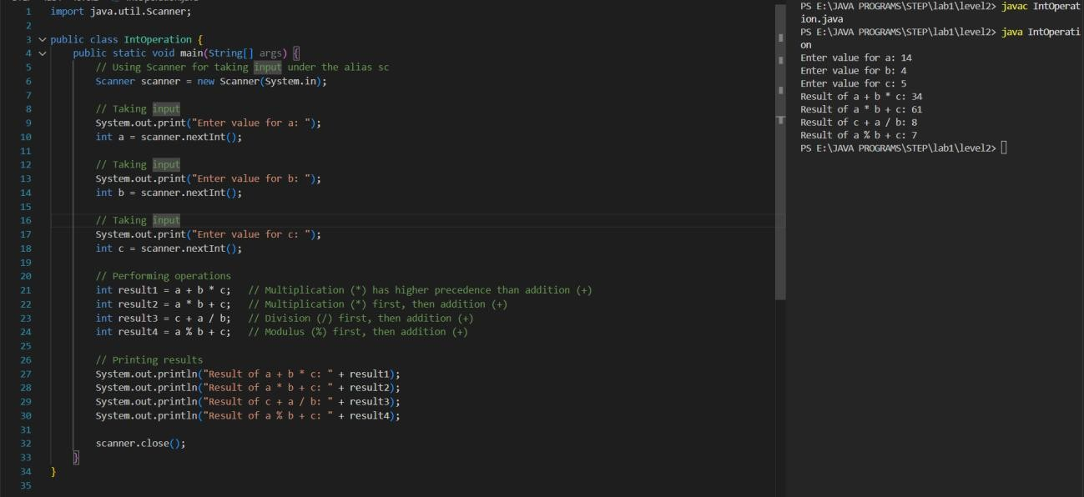

1. Similarly, write the ***DoubleOpt*** program by taking double values and doing the same operations.

